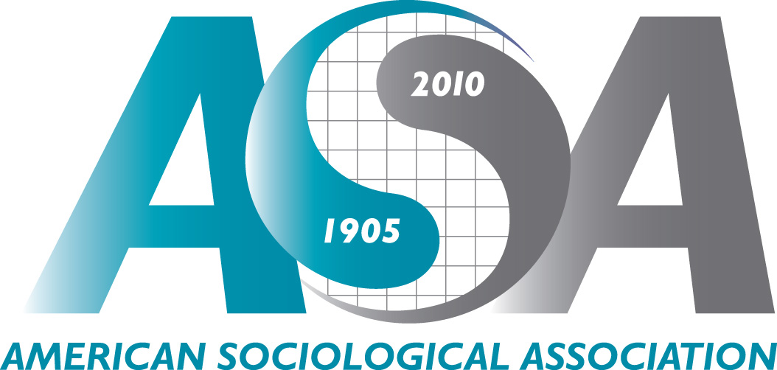
Annual Meeting Press Policy

ASA’s 105th Annual Meeting: Toward a Sociology of Citizenship
August 14-17, 2010 ▪ Hilton Atlanta & Atlanta Marriott Marquis ▪ Atlanta
http://www.asanet.org/2010Homepage.cfm

The American Sociological Association’s 2010 Annual Meeting is expected to bring about 5,000 of the nation’s leading sociological minds to Atlanta August 14 to 17.

This year’s theme, “Toward a Sociology of Citizenship,” is intended to stimulate development of sociological approaches to a comparative transnational study of citizenship. A searchable preliminary program is available online at http://www.asanet.org/2010Program.cfm (click on “Search Preliminary Program” icon).

Complimentary press registration to ASA’s Annual Meeting is provided to credentialed members of the news media. Access is provided to working journalists at no cost to allow relevant sociological research to be reported to the public.

Eligibility Requirements
Press registrants may be asked to provide verification of editorial status. Accepted credentials include an editorial-titled business card from a news media outlet, a recent bylined article, or a letter of assignment from the media organization represented.

Press registration requests submitted prior to August 6 will be confirmed before the Annual Meeting. Onsite media registration will be available in the ASA Annual Meeting press room, but advance registration is strongly recommended.

ASA reserves the right to refuse complimentary press registration to any individual.

Onsite Guidelines
- Onsite press registration is available in the ASA Annual Meeting press room (see hours and location below).
- Registered press are required to wear ASA press badges at all times while onsite at the ASA Annual Meeting.
- Still photography, video and/or audio recording are encouraged but must be pre-approved by ASA’s Public Information Office (pubinfo@asanet.org).
- The Annual Meeting’s plenary sessions, presidential panels, and thematic and other sessions feature sociological research and perspectives on important and timely topics. These sessions are open to the media.

Press Room Availability & Policies
ASA provides a press room onsite in the Room 202 of the Hilton Atlanta for the convenience of registered media. The press room is equipped with phone, printer, and computers with Internet access. ASA press registration is required for use of the press room.

Staff from ASA’s Public Information Office is available during the meeting to help facilitate interviews with ASA leadership, speakers, and research authors.

Press Room Hours

Friday, August 13: 1:30 – 5:30 pm Saturday, August 14: 8 am – 5:30 pm Sunday, August 15: 8 am – 5:30 pm

Monday, August 16: 8 am – 5:30 pm Tuesday, August 17: 8 am – 3 pm

*Please note that the press room opens the afternoon of Friday, August 13 to coincide with the Annual Meeting’s Opening Plenary Session that night.
Annual Meeting Press Registration

American Sociological Association’s 2010 Annual Meeting:
Toward a Sociology of Citizenship

Please complete all areas below and return to ASA’s Public Information Office by August 6, 2010.

by mail: by e-mail: by fax:
ASA Public Information Office pubinfo@asanet.org (202) 638-0882
ATTN: Daniel Fowler
1430 K Street, NW
Suite 600
Washington, DC 20005

After August 6, registration will be available onsite in the press room (Room 202, Hilton Atlanta)
at the ASA Annual Meeting.

Questions may be directed to Daniel Fowler, ASA Media Relations and Public Affairs Officer, at pubinfo@asanet.org or (202) 527-7885.

Name: | Media Outlet:
Position/Title: | Beat:
E-mail: | Web site:
Office Phone: | Onsite Phone:
Address: | Preferred Method of Contact:

Please register me as a credentialed journalist to attend the ASA 2010 Annual Meeting in Atlanta.
I have read and agree to uphold the conditions of ASA’s Annual Meeting Press Policy.

I am unable to attend, but please add me to your media list.

Additional comments/special requests:

